# [***Law & Order: Organized Crime EP Matt Olmstead Steps Down as Showrunner on Chris Meloni-Led SVU Spinoff***](https://tvline.com/2020/10/02/law-and-order-organized-crime-matt-olmstead-showrunner-stepping-down-season-1-nbc/#!)

By [Kimberly Roots](https://tvline.com/author/kimberly-roots/) / October 2 2020, 10:11 AM PDT

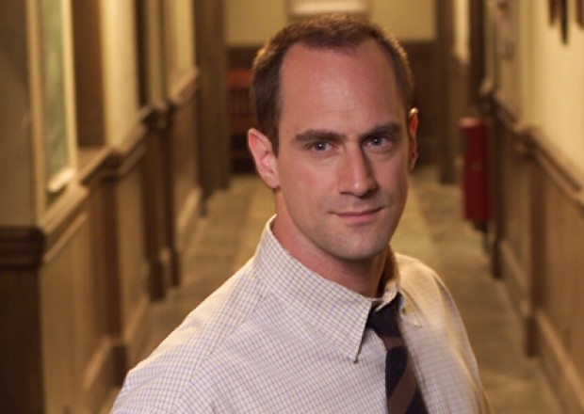

Courtesy of NBC

* [**21**](https://tvline.com/2020/10/02/law-and-order-organized-crime-matt-olmstead-showrunner-stepping-down-season-1-nbc/#comments)

*Law and Order: Organized Crime*‘s boss is already out.

*Chicago P.D./Chicago Fire* alum Matt Olmstead is stepping down as showrunner on the highly anticipated *SVU* spinoff, TVLine has confirmed. [THR.com](https://www.hollywoodreporter.com/live-feed/chris-melonis-law-order-svu-spinoff-delayed-at-nbc-amid-showrunner-change-exclusive) first reported the behind-the-scenes change.

Though originally slated to air Thursdays at 10/9c as part of NBC’s Fall 2020 lineup, the Chris Meloni-led drama’s status was [changed in August](https://tvline.com/2020/08/27/nbc-premiere-dates-fall-2020-this-is-us/). Now, the drama is slated to premiere sometime in 2021.

We hear that production on *Organized Crime* has been pushed back to deal with the staffing change; no word yet on who’ll replace Olmstead or on whether — or how much — the situation will affect the targeted 2021 premiere.

The newest offshoot of Dick Wolf’s long-running franchise was [ordered to series in March](https://tvline.com/2020/03/31/chris-meloni-svu-returns-stabler-new-spinoff-nbc/) and features Meloni reprising the character of Elliot Stabler. His comeback is expected to include his first appearance on [*Law & Order: SVU*](https://tvline.com/tag/law-order-svu/) since exiting the show nearly a decade ago. (Meloni departed *SVU* after negotiations related to his contract broke down at the end of Season 12. When Season 13 started, Stabler had retired from the police force without saying anything to his co-workers; Olivia learned the devastating news at the same time as the audience did.)

In *Organized Crime*, Stabler is a boss in the Organized Crime unit of the New York City Police Department. Per the spinoff’s official logline, the series will deal with the realities of modern policing and will take place as Liv’s old partner returns to the department “after [a devastating personal loss](https://tvline.com/2020/06/16/law-and-order-svu-spinoff-stabler-death-dies-organized-crime/).”

***If you like TVLine, you'll LOVE our email news alerts!*** [***Click here to subscribe.***](https://cloud.email.tvline.com/signup/)